Random Forest
A Random Forest is an ensemble learning method used for both classification and regression tasks. It operates by constructing a multitude of decision trees during training and outputting the class that is the mode of the classes (for classification) or mean prediction (for regression) of the individual trees. It combines the concepts of bagging (bootstrap aggregating) and random feature selection, leading to improved accuracy and robustness.
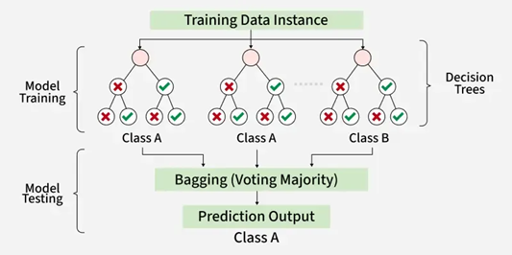

Bootstrapping is a sampling technique where you randomly select samples from your dataset with replacement.
“With replacement” → the same data point can appear multiple times in the sample.
The size of the bootstrap sample is usually the same as the original dataset.
Example: Original dataset: [A, B, C, D, E]
One bootstrap sample could be: [A, C, D, C, B]
Notice C appears twice, and E is missing.
Purpose in Random Forest:
Each tree is trained on a different bootstrap sample → trees are diverse.
Bagging = Bootstrap Aggregating. It is an ensemble method where:
- You create multiple bootstrap samples from the training data.
- Train a separate model (e.g., decision tree) on each bootstrap sample.
- Combine the predictions of all models:
  - Classification: majority vote
  - Regression: average
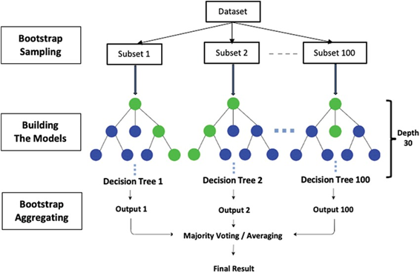
Random Feature Selection
Random feature selection, also known as the random subspace method or feature bagging, is a technique primarily employed in ensemble learning methods like Random Forests to enhance model robustness and reduce variance. Instead of considering all available features at each split point when building individual decision trees within an ensemble, random feature selection involves randomly selecting a subset of features. This subset is then used to determine the best split for that particular node in the tree. This process is repeated for each split and for each tree in the ensemble.

Example: Predict if a fruit is Apple or Orange
We have two features:
- Weight (grams)
- Color (Red = 1, Orange = 0)
Training data:
Fruit | Weight | Color (Red=1, Orange=0) | Label
F1 | 150 | 1 | Apple
F2 | 160 | 1 | Apple
F3 | 170 | 0 | Orange
F4 | 140 | 1 | Apple
F5 | 180 | 0 | Orange

Step 1: Build Random Trees
We grow 3 random trees (small example):
- Tree 1 (trained on F1, F2, F3, F4)
Rule: If Color = Red → Apple, else → Orange
- Tree 2 (trained on F2, F3, F5)
Rule: If Weight < 165 → Apple, else → Orange
- Tree 3 (trained on F1, F4, F5)
Rule: If Weight > 160 → Orange, else → Apple
Step 2: Prediction
Suppose a new fruit comes in:
- Weight = 155 g, Color = Red (1)
Predictions:
- Tree 1: Color = Red → Apple
- Tree 2: Weight < 165 → Apple
- Tree 3: Weight > 160? No (155 ≤ 160) → Apple
Step 3: Random Forest Vote
- Apple = 3 votes
- Orange = 0 votes
Final Prediction = Apple

Feature Importance
It measures how useful or relevant a feature is in predicting the target variable. In machine learning, some features have more predictive power than others and identifying important features can improve model accuracy, reduce overfitting, and make the model interpretable.
Example: Predicting heart disease:
  - Age might be more important than “Hair Color”.
  - Cholesterol level might carry more weight than “Favorite Color”.
Chi Square test
The Chi-Square test was introduced by Karl Pearson in 1900. He needed a symbol to represent a measure of deviation between observed and expected frequencies. In mathematics and statistics, Greek letters are often used for parameters, test statistics, or constants.
Chi-Square is a statistical measure used to test the relationship between categorical variables. It compares observed data (what you actually collected) with expected data (what you would expect if there were no relationship).

Example: Predicting Pass/Fail Based on Study Hours
We have a small dataset of students:
Study Hours | Pass | Fail
Low | 5 | 15
Medium | 15 | 5
High | 30 | 0

Study Hours | Pass | Fail | Row Total
Low | 5 | 15 | 20
Medium | 15 | 5 | 20
High | 30 | 0 | 30
Column Total | 50 | 20 | 70
We want to see if Study Hours affect the outcome (Pass/Fail).

Step 1: Set Hypotheses
- Null hypothesis (H₀): Study Hours and Pass/Fail are independent (no effect).
- Alternative hypothesis (H₁): Study Hours and Pass/Fail are dependent (effect exists).

Step 2: Compute Expected Frequencies
Use the formula:
$$E=\frac{\left(\text{row total}\right)×\left(\text{column total}\right)}{\text{grand total}}$$
- Low-Pass: $E=\frac{20×50}{70}≈14.29$
- Low-Fail: $E=\frac{20×20}{70}≈5.71$
- Medium-Pass: $E=\frac{20×50}{70}≈14.29$
- Medium-Fail: $E=\frac{20×20}{70}≈5.71$
- High-Pass: $E=\frac{30×50}{70}≈21.43$
- High-Fail: $E=\frac{30×20}{70}≈8.57$

Step 3: Compute χ² Statistic
$$χ^{2}=∑\frac{(O-E)^{2}}{E}$$
Cell | O | E | (O-E)²/E
Low-Pass | 5 | 14.29 | 6.05
Low-Fail | 15 | 5.71 | 15.08
Medium-Pass | 15 | 14.29 | 0.035
Medium-Fail | 5 | 5.71 | 0.088
High-Pass | 30 | 21.43 | 3.42
High-Fail | 0 | 8.57 | 8.57
$$χ^{2}≈6.05+15.08+0.035+0.088+3.42+8.57=33.24$$

Step 4: Degrees of Freedom
$$df=\left(\text{rows}-1\right)×\left(\text{columns}-1\right)=(3-1)×(2-1)=2$$
- Only 2 cells can vary freely; the rest are determined by row/column totals.

Step 5: Find χ² Critical Value
- Significance level: α = 0.05
- From Chi-Square table or Python: χ² critical ≈ 5.99
Compare:
$$χ_{\text{calculated}}^{2}=33.24>5.99=χ_{\text{critical}}^{2}$$

Step 6: Interpretation
- χ² is much bigger than the critical value → reject H₀
- Study Hours affect Pass/Fail outcome → it is an important feature for the model.
Important Points
- Expected values = “what would happen if there was no effect”
- Observed values = “what actually happened”
- χ² measures the difference between observed and expected.
- If difference is large → feature matters.
- Degrees of freedom = number of “free cells” in the table
- Critical value = threshold for deciding if difference is significant

Example: Does Favorite Color Affect Pass/Fail?
Observed data (O):
Color | Pass | Fail | Row Total
Red | 17 | 18 | 35
Blue | 18 | 17 | 35
Column Total | 35 | 35 | 70

Step 1: Set Hypotheses
- H₀: Favorite Color and Pass/Fail are independent.
- H₁: Favorite Color and Pass/Fail are dependent.

Step 2: Compute Expected Frequencies (E)
Formula:
$$E=\frac{\left(\text{row total}\right)×\left(\text{column total}\right)}{\text{grand total}}$$
- Red-Pass: $E=\frac{35×35}{70}=17.5$
- Red-Fail: $E=\frac{35×35}{70}=17.5$
- Blue-Pass: $E=17.5$
- Blue-Fail: $E=17.5$

Step 3: Compute χ² Statistic
$$χ^{2}=∑\frac{(O-E)^{2}}{E}$$
Cell | O | E | (O-E)²/E
Red-Pass | 17 | 17.5 | (17-17.5)²/17.5 = 0.0143
Red-Fail | 18 | 17.5 | (18-17.5)²/17.5 = 0.0143
Blue-Pass | 18 | 17.5 | 0.0143
Blue-Fail | 17 | 17.5 | 0.0143
$$χ^{2}≈0.0143×4=0.0572$$

Step 4: Degrees of Freedom
$$df=\left(\text{rows}-1\right)×\left(\text{columns}-1\right)=(2-1)×(2-1)=1$$

Step 5: Find χ² Critical Value
- α = 0.05
- df = 1 → χ² critical ≈ 3.841 (from Chi-Square table)
Compare:
$$χ_{\text{calculated}}^{2}=0.0572<3.841=χ_{\text{critical}}^{2}$$

Step 6: Interpretation
- Calculated χ² < critical value → fail to reject H₀
- Conclusion: Favorite Color does NOT affect Pass/Fail outcome

Color | Pass | Fail | Row Total
Red | 17 | 18 | 35
Blue | 18 | 17 | 35
Green | 10 | 15 | 25
Column Total | 45 | 50 | 95

